Proposed Updates: 2022 Aquifer Risk Map

The Aquifer Risk Map estimates water quality risk of domestic wells and state small water systems, which are not regulated or routinely sampled by the state. The map estimates the risk to these unregulated systems by averaging existing, depth-filtered water quality data from the last 20 years to identify areas where raw source groundwater may be above the maximum contaminant level. The 2020 version of the Aquifer Risk Map is [available online](https://gispublic.waterboards.ca.gov/portal/apps/webappviewer/index.html?id=17825b2b791d4004b547d316af7ac5cb), and will be updated with new data annually (January).

# Proposed Updates

1. **Re-focus Aquifer Risk Map to section level data instead of census block group risk percentile scores**. We understand that section-level data summaries provided the most useful data in 2020 and is the primary level for which we have domestic well record counts. The census block group percentile calculation methodology had issues with correcting for small, urban census block group areas. A reason for using census block groups was to combine with drought risk data but these data can be converted to the section level for incorporation in the Aquifer Risk Map (see proposed update #3). Instead, we recommend that the updated Aquifer Risk Map should display section level water quality, with a census block group outline overlay that indicates DAC/SDAC census block groups.

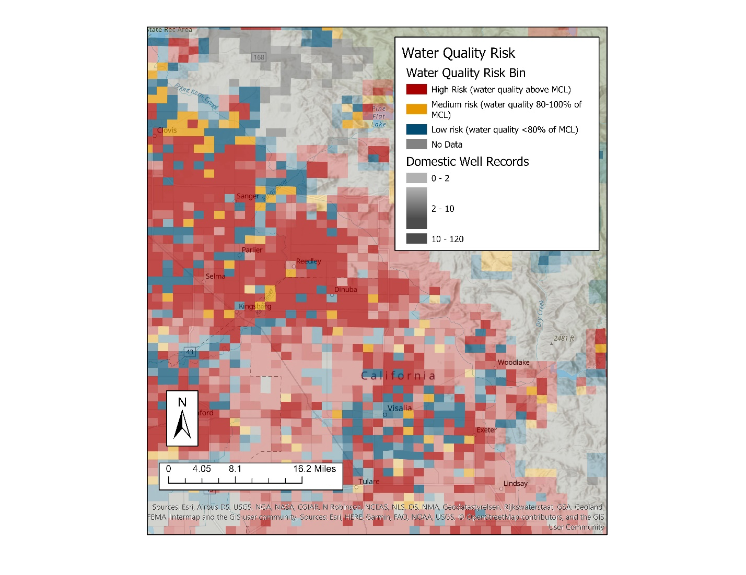

1. **Change definition of “recent” results from 2 to 5 years.** Many data sources are not sampled annually (and DDW compliance cycle is 3 years), so this adjustment allows more high-risk data points to be included. This update increases the number of “high” risk domestic wells and state small water systems. Comparison with ILRP nitrate data indicated that this update improved Aquifer Risk Map accuracy.
2. **Incorporate water quality data from GeoTracker data** (also see proposed update #1). Including groundwater quality data from cleanup sites (GeoTracker data) results in expanded map coverage. GeoTracker data would only be included in the map if the monitoring well is at least 100 feet deep and if the well meets the domestic depth filtering criteria in order to screen out very shallow groundwater data that may not be representative of domestic well depths. However, due to risk percentile calculation methodology for census block groups in the 2020 Aquifer Risk Map, use of the GeoTracker data results in a disproportionate increase in the risk score for of small, urban census block groups. Re-focusing of the data to the Section level (recommendation #1) addresses this problem. This update increases the number of “high” risk domestic wells and state small water systems. Fifty percent of this increase occurs in Riverside, Santa Clara, Calaveras, Mendocino, San Bernardino, Sonoma, and Merced counties. This update could not be compared with ILRP nitrate data, as there was no GeoTracker nitrate data available for the areas with sampled domestic wells.

Table . Domestic Well Water Quality Risk Counts – proposed Aquifer Risk Map updates

|  |  |  |  |  |  |
| --- | --- | --- | --- | --- | --- |
| Water Quality Risk | 2021 ARM | 2022 ARM (all proposed updates) | 2022 ARM (new data only) | 2022 ARM (include GT data) | 2022 ARM ("recent" = 5 years) |
| High WQ Risk (> MCL) | 77,973 (24%) | 92,635 (30%) | 75,918 (24%) | 79,985 (26%) | 88,558 (28%) |
| Medium WQ Risk (80%-100% MCL) | 15,791 (5%) | 17,078 (5%) | 18,310 (6%) | 18,029  (6%) | 17,632 (6%) |
| Low WQ Risk (<80% MCL) | 147,185 (43%) | 134,282 (43%) | 147,924 (47%) | 145,981 (47%) | 135,962 (44%) |
| No WQ data | 84,800 (26%) | 68,192 (22%) | 70,035 (22%) | 68,192 (22%) | 70,035 (22%) |

Table . State Small Water Systems Water Quality Risk Counts - proposed Aquifer Risk Map updates

|  |  |  |  |  |  |
| --- | --- | --- | --- | --- | --- |
| Water Quality Risk | 2021 ARM | 2022 ARM (all proposed updates) | 2022 ARM (new data only) | 2022 ARM (include GT data) | 2022 ARM ("recent" = 5 years) |
| High WQ Risk (> MCL) | 611 (42%) | 716 (49%) | 602 (41%) | 636 (43%) | 683 (47%) |
| Medium WQ Risk (80-100% MCL) | 71 (5%) | 99 (7%) | 107 (7%) | 101 (7%) | 104 (7%) |
| Low WQ Risk (<80% MCL) | 553 (38%) | 484 (33%) | 578 (40%) | 562 (38%) | 500 (34%) |
| No WQ Data | 228 (16%) | 164 (11%) | 176 (12%) | 164 (11%) | 176 (12%) |

1. **Incorporate drought risk data**. The Department of Water Resources County Drought Advisory Group calculated drought risk per census block group for [rural/self-supplied communities](https://tableau.cnra.ca.gov/t/DWR_IntegratedDataAnalysisBranch/views/DWRDroughtRiskExplorer-RuralCommunitesMarch2021/Dashboard?%3AshowAppBanner=false&%3Adisplay_count=n&%3AshowVizHome=n&%3Aorigin=viz_share_link&%3AisGuestRedirectFromVizportal=y&%3Aembed=y). These data were modified for use in the 2022 Aquifer Risk Map to avoid duplicating the water quality risk factor (RC2i). The modification consisted of a re-calculation of the current conditions risk factor (Score_RC2) as:

The new current conditions risk factor (Score_RC2mean_NEW) was then used to recalculate the final risk score. No other weighing or risk factors were changed in the final score calculation. The modified scores were then grouped into the upper 20th percentile (modified scores of 55 – 100), the middle 20th – 80th percentile (modified scores 28 – 55) and the lower 20th percentile (modified scores of 0 – 28). The modified drought risk scores will be visible as map layer on the online Aquifer Risk Map.

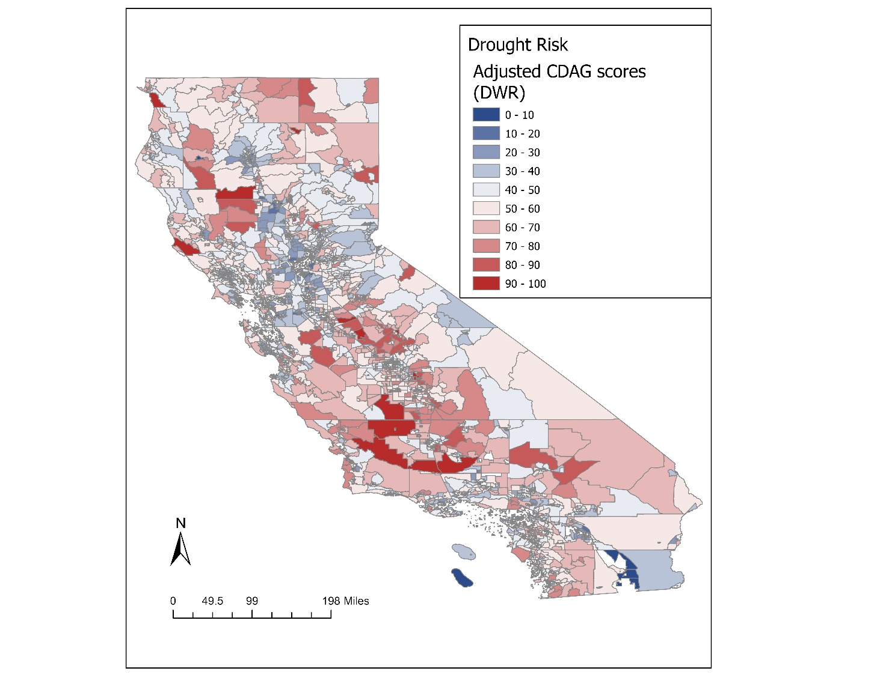

Figure . Example of modified drought risk score layer display for online Aquifer Risk Map.

Aquifer Risk Map data was summarized at the block group level by counting the number of domestic wells and state small water systems in each water quality risk bin (high risk: water quality estimate > MCL; medium risk: water quality estimate 80%-100% of MCL; low risk: water quality estimate < 80% of MCL). These counts were then compared to the modified drought risk scores of each block group.

The graphs below show the statewide distribution of domestic wells and state small water systems separated by modified drought risk (columns) and water quality risk (colors). Statewide, there may be up to 41,000 domestic well records and approximately 159 state small water systems in areas where the water quality is estimated to be above the MCL and where the modified drought risk score is in the upper 20th percentile. Fresno and Tulare counties account for one fourth of these domestic wells.

It is important to note that drought risk of an individual system or domestic well is dependent on well depth, local conditions, and other factors not represented here. Similarly, the water quality of an individual system or domestic well is best assessed through testing of that well, and the water quality risk presented here is only an estimate based on data from surrounding wells.

“Current conditions” water level data will also be displayed as a live link from the Department of Water Resources. This data layer displays current groundwater level in comparison to historic levels, highlighting wells that are at or close to historic lows. Although this coverage is not statewide and does not represent domestic wells, it does give an up-to-date look at water level data in most state basins.

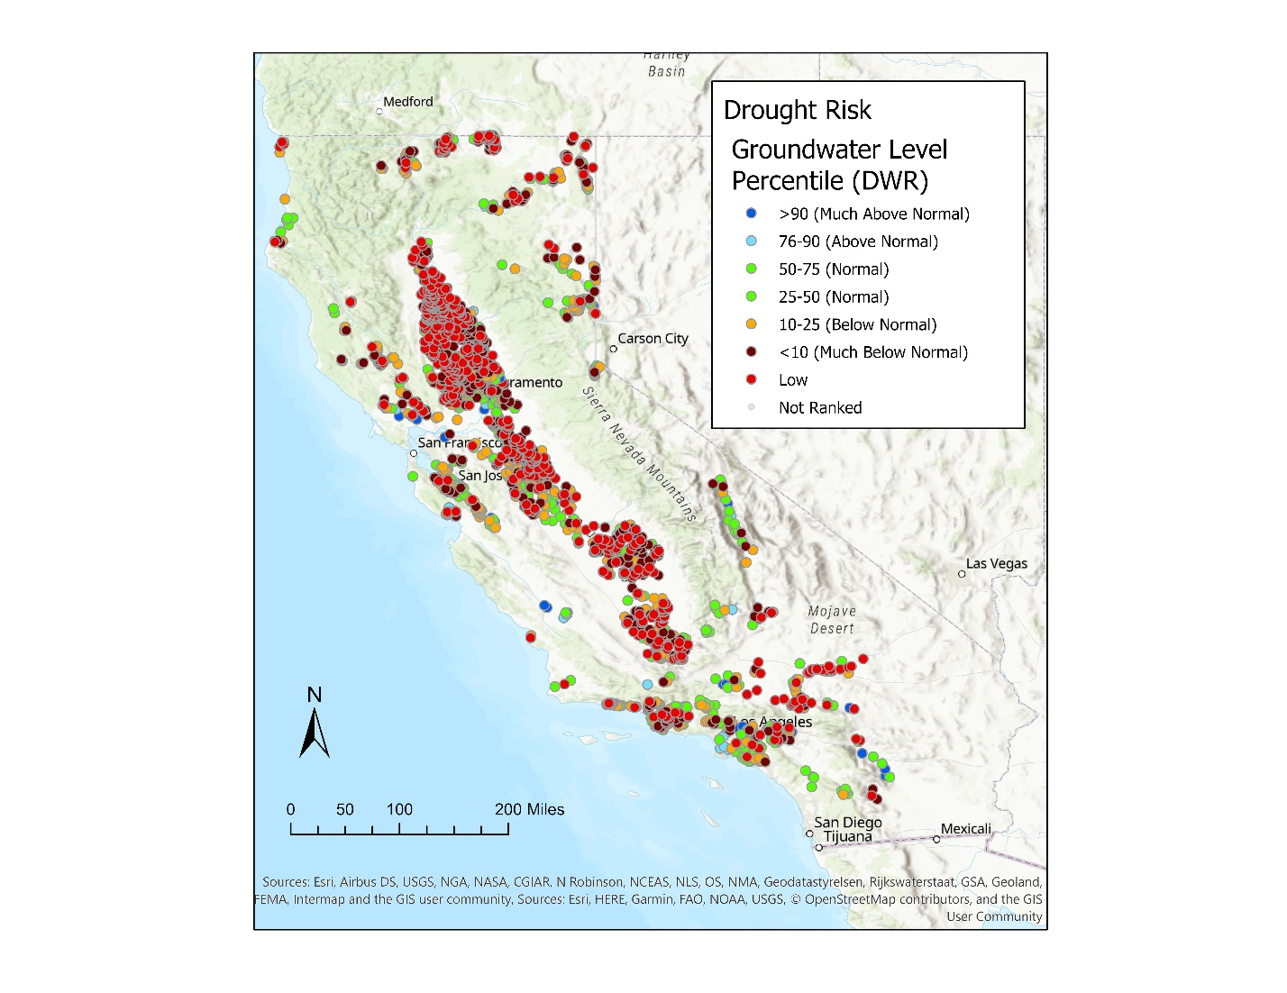

Figure . Screenshot of the "current conditions" groundwater level data from the Department of Water Resources. The color shows the current groundwater level conditions of a well compared to historic average.

# Other updates

* New water quality data and increased domestic well sampling through the Irrigated Lands Regulatory Program will improve the data coverage of the 2021 Aquifer Risk Map. If no other methodology updates are applied, the 2021 Aquifer Risk Map will have more “high” risk domestic wells and less “high” risk state small water systems than the 2020 Aquifer Risk Map.
* There are two technical updates to the Aquifer Risk Map code that slightly change the map. Firstly, contaminants of concern will now only appear once in risk lists for point, section, and census block group. Previously, if a contaminant had a long-term average over the MCL and a recent value at 0.9 times the MCL, that contaminant would count as both a “high-risk” and “medium-risk”. In the updated version, this will only count once as a “high-risk” contaminant. Secondly, “neighbor” values will be determined by contaminant/section pairs instead of just by section. Previously, if a section had any water quality data, it could not be represented by neighbor values even if that section only had water quality data from one contaminant and neighboring sections had water quality results for multiple contaminants.
* There will be a slight change to the way domestic well records are queried from the Online System for Well Completion Reports (OSWCR). Previously well completion records that contained the word “domestic” were queried, excluding “domestic” wells that were drilled prior to 1970. For this update, we propose to also exclude well completion reports that have “destruction” in their record type name. This should help to avoid counting destruction records as active domestic wells. This slightly reduces the total number of domestic well records from ~325,000 to ~312,000. If future improvements are made to domestic well location and record data we will continue to improve this aspect of the Aquifer Risk Map.
* Race and ethnicity data from the 2020 census will be included as an informational layer on the online map. The “census block group data” layer will include all demographic information that is available at the block group level, including median household income (disadvantaged community status) and race and ethnicity data. The drought risk scores for rural and self-supplied communities are also available at the block group level and will be displayed in this data layer.

|  |  |
| --- | --- |
| GEOID | 060670092012 |
| County | Sacramento County |
| High-Risk Domestic Wells | 34.67 |
| Total Domestic Wells | 153.21 |
| High-Risk State Small Water Systems | 0 |
| Total State Small Water Systems | 0 |
| Median Household Income (2018 ACS) | 51354 |
| DAC/SDAC status | DAC |
| DWR Drought Risk Score | 48.85 |
| Total Population | 1036 |
| Hispanic | 301 |
| White | 465 |
| Black | 39 |
| American Indian/Native American | 7 |
| Asian | 144 |
| Native Hawaiian/Pacific Islander | 16 |
| Other/Multiple | 64 |

Figure . Example of data displayed in the census block group data layer.

* Domestic well weighting (emphasizing data from sampled domestic wells) was considered but is not proposed as an update at this time. Increasing the influence of domestic well water quality results on section water quality estimates did not improve map accuracy according to the comparison with 2020 ILRP nitrate data. Furthermore, weighting data from domestic wells did not result in any change to the statewide counts of “high”, “medium”, and “low” risk domestic wells or state small water system.

# Aquifer Risk Map Accuracy – Comparison with sampled domestic wells

The estimated nitrate water quality was compared to actual domestic well nitrate data collected through the Irrigated Lands Regulatory Program (ILRP) from September 2020 through May 2021 to assess the accuracy of the 2020 risk map. These ILRP nitrate results were not used to calculate the 2020 Aquifer Risk Map water quality risk estimates. As a result, these ILRP results provide a control group for comparing to the predicted water quality in the 2020 Aquifer Risk Map. For 74% (1,267) of ILRP samples the 2020 Aquifer Risk Map accurately estimated the ILRP nitrate results or was close to estimating the ILRP nitrate results. For 15% (258) of ILRP samples the 2020 Aquifer Risk Map estimated a “high” nitrate risk when the sampled result was “low” and for 11% (185) of ILRP samples the 2020 Aquifer Risk Map estimated a “low” nitrate risk when the sampled results was “high”.

# Aquifer Risk Map 2021-2022 analysis

